**Clauses**

**Main clause** – A simple sentence that contains a subject and a verb. It makes sense on its own: **I went** to school.

**Subordinate clause** – Contains a subordinating conjunction. Adds detail to a main clause; is not a full sentence. The subordinate clause can appear at the start, end or middle of a sentence.

I went to school **while my brother stayed at home.**

Or

**While my brother stayed at home**, I went to school

**Punctuation**

**Semi-colon (;) –** joins two related independent clauses together

**Dashes (–), brackets (), commas (,)**

Used within a sentence to add additional information - Parenthesis

The cat (that didn’t belong to me) was black.

**Determiners –** A word before a [noun](http://www.theschoolrun.com/what-is-a-noun) and identifies the noun in further detail.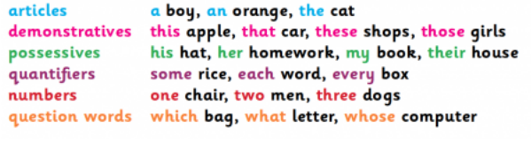



**Passive and Active Voice**

Active – Subject performs the action.

Passive – When the subject has something done to it. (By zombies)

The cat chased the mouse.

The mouse was chased by the cat.

**Commands, Questions and Statements**

Commands begin with an imperative

verb. **Wash** your hands.

Questions expect an answer in return.

Did you enjoy the trip**?**

Statements tell the reader something.

The leaves fall off trees in autumn.

**Modal Verbs** – Show degree of certainty or possibility.

could, should, would, might, often, ought, can

Comma

Inverted comma

**Parts of speech**

**The child asked, “What are your plans for the weekend?”**

Inverted comma capital letter closing punctuation

**Subordinate Conjunctions**

Joins a subordinate clause and

a main clause.

While

After

Because

Before

If

Though

Since

Because I go to school, I get to

learn about grammar.

I get to learn about grammar

because I go to school.

**Tenses – Tells us when in time an action took place**

|  |  |  |
| --- | --- | --- |
| **Past** | **Present** | **Future** |
| **Simple Past**  I walk**ed**  We **saw**  You **ran** | **Simple Present**  I **walk**  We **see**  You **run** | **Simple Future**  I **will** walk  We **will** see  You **will** run |
| **Past Continuous/**  **Progressive**  I **was** walk**ing**  We **were** see**in**g  You **were** runni**ng** | **Present Continuous/**  **Progressive**  I **am** walk**ing**  We **are** see**ing**  You **are** runn**ing** | **Future Continuous/**  **Progressive**  I **will be** walk**ing**  We **will be** see**ing**  You **will be** runn**ing** |
| **Past Perfect**  I **had** walk**ed**  We **had** seen  You **had** run | **Present Perfect**  I **have walked**  We **have** seen  You **have** run | **Future Perfect**  I **will have** walk**ed**  We **will have** seen  You **will have** run |

YEAR 6 SPAG KNOWLEDGE ORGANISER

**More Punctuation**

Hyphen (-) – Creates compound words to give a clear meaning.

The **man-eating** shark.

The man eatingshark.

**Apostrophes**

For possession: Shows us that something belongs to the subject.

My Mum’s bag.

For omission: Shows us that a letter has been missed out to create informality.

Don’t do that.

Do not do that.

**Subjunctive form/mood**

A verb form to express wishes, hopes, commands, demands or suggestions.

If I **were** the prime minister…

I suggest that you **take** the deal.

**Noun Phrases –** Gives detail about a noun but does not contain a verb:

An ancient book in a leather sleeve was hidden in the library.

**Coordinating Conjunctions**

Joins two independent (main) clauses.

For

And

Nor

But

Yet

So

I like ice cream **and** I like cake**.**